**Table of Contents**

Acknowledgement: 2

Project Overview 3

Problem/Opportunity: 3

Goals: 3

Objectives: 3

Project Description: 3

Technical Details: 3

Flow Chart: 4

Algorithm: 5

Basic Functions: 5

Distribution of tasks among members: 8

Timing Chart: 8

8

Source Code: 9

Output: 10

11

References: 13

Acknowledgement:

We would like to express our deepest thanks of gratitude to our teacher **Miss Nazia Ashraf** who has given has opportunity to research and learn new things and then to make a simple program. During the completion of this project we have learned many new and important things which will be very helpful for us in the future. Once again very special thanks to her.

Project Overview

Problem/Opportunity:

In a secondary school, the teachers of the school are using old means of analyzing students’ performance, taking tests. This has resulted a slow and possibly unfair test result.

Goals:

1. To make it easy for the management of the school to analyze the performance of the students and take immediate actions for that.
2. To make it easy for the teachers to take test easily with immediate results, analyze the performance of the students easily and make reports easily.
3. To make it easy for the students to give test with no time and disturbance and get immediate results and scores.

Objectives:

1. To increase efficiency and effectiveness of students’ testing system.
2. To improve the current method of analyzing performance of the students and reduce system redundancy.

Project Description:

In this quiz master, we created a program to improve testing system. For that we used filing, many functions and arrays using C Programming Language.

Technical Details:

1. Working Computer
2. IDE

Flow Chart:

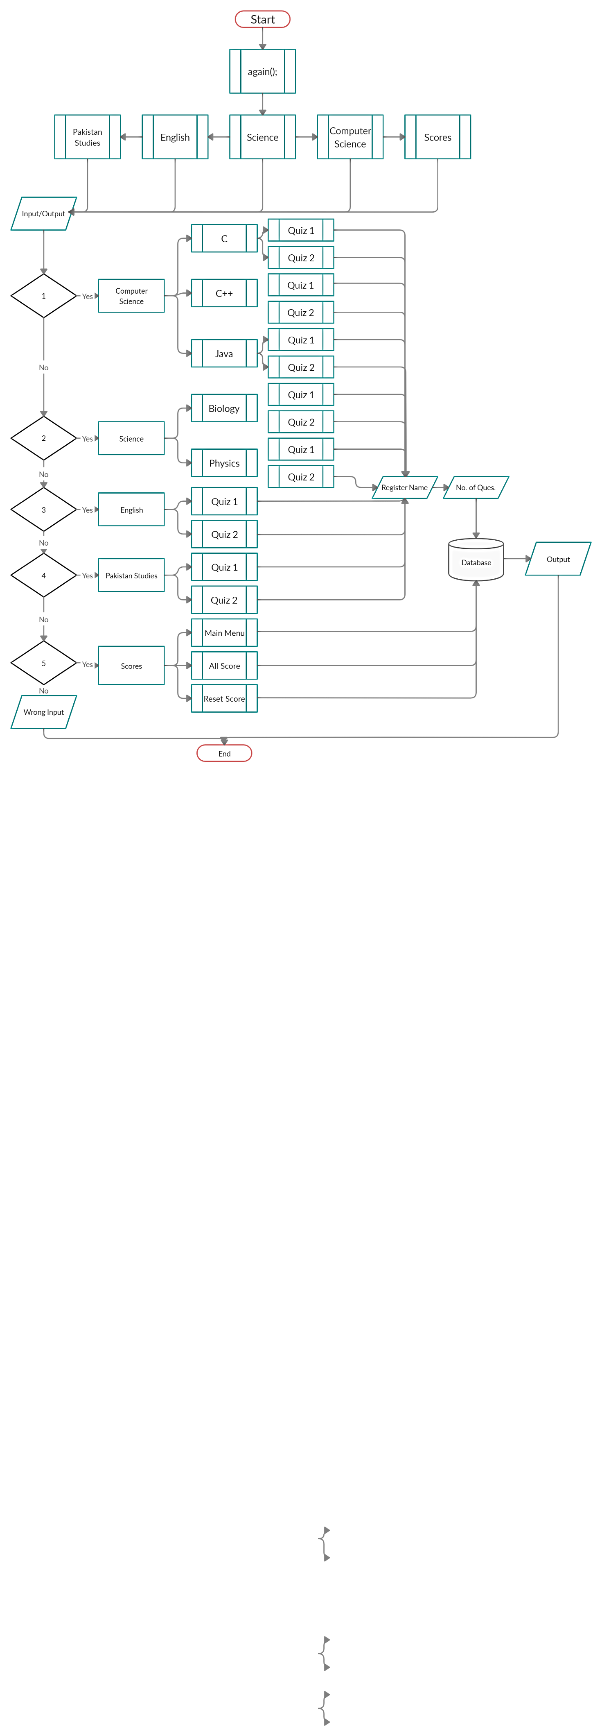

mainmenu();

Algorithm:

1. Start
2. Call mainmenu() function.
3. Get Input (by mainmenu()).
4. Call specific function according to user input.
5. Get Input to get name of the user.
6. Get Input to ask no. of questions.
7. Processing specific function. (Line 4)
8. If the user has given 3 consecutive wrong answers, program will terminate.
9. Get the user to ask to jump to main menu, play again or exit.
10. If the user has done quiz without giving 3 consecutive wrong answers, then the result will show on the screen.
11. Save user score against user name.
12. If the previous marks of the user is less, then the current marks will be overwritten.
13. Get the user to ask to jump to main menu, play again or exit.
14. Exit

Basic Functions:

1. **void mainmenu();**

This function turns a user on a main menu.

1. **void computerscience();**

This function turns a user on a Computer Science Section Where C ,C++,JAVA Function are call.

1. **void science();**

This function turns a user on a Science Section Where Physics and Biology Function are call.

1. **void english();**

This function turns a user on a English Section Where English LEVEL 1&2 function are call.

1. **void pakistanstudies();**

This function turns a user on a Pakistan studies Section.

1. **void cdata();**

This Type of functions end with data are used to turns a user to the Specific Data Acces (Show Record,Delete Record)

1. **void reset_score_c();**

**void disp_record_c();**

This Type of functions turns the information to save ,display and reset .

1. **void quizc1();**

This function includes all questions regarding C language (Level 1)..

1. **void quizc2();**

This function also includes all questions regarding C language (Level 2).

1. **void qucc1();**

This function includes all questions regarding C++ Programming Language (Level 1).

1. **void qucc2();**

This function includes all questions regarding C++ Programming Language (Level 2).

1. **void java1();**

This function includes all questions regarding Java Programming language(Level 1).

1. **void java2();**

This function includes all questions regarding Java Programming language (Level 2).

1. **void physics1();**

This function includes all questions regarding Physics(Level 1).

1. **void physics2();**

This function includes all questions regarding Physics (Level 2).

1. **void english1();**

This function includes all questions regarding English Language(Level 1).

1. **void english2();**

This function includes all questions regarding English Language (Level 2).

1. **void biology1();**

This function includes all questions regarding Biology(Level 1).

1. **void biology2();**

This function includes all questions regarding Biology(Level 2).

1. **void pakistanstudies1();**

This function includes all questions regarding Pakistan Studies(Level 1).

1. **void switchmainm();**

This function turns a user on main menu or to score menu.

1. **void scores();**

This function lets the user to check the highest score of the user.

1. **void allscore();**

This function is used to print scores of all the categories / subjects.

1. **void allreset();**

This function will reset all the saved record.

There are 82 functions are used for making the program reliable and user friendly options.

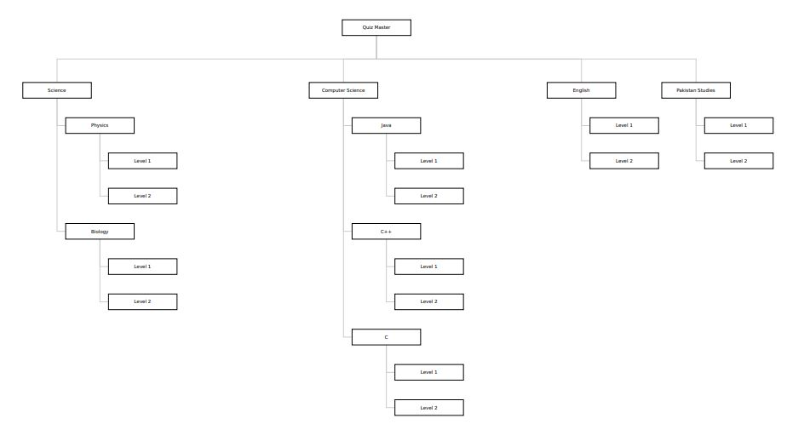

**Project Workdown (Quiz Master)**

Distribution of tasks among members:

|  |  |  |  |  |
| --- | --- | --- | --- | --- |
| **Names** | Muhammad Azhar | Kirshan Lal | Muhammad Haseeb | Mehar Khan Niazi |
| **Task** | Coding + Report | Coding + Data Gathering | Coding + Testing | Coding + Report |

Timing Chart:

Source Code:

Output:

**No compiling error: Computer Science Sub-Section:**

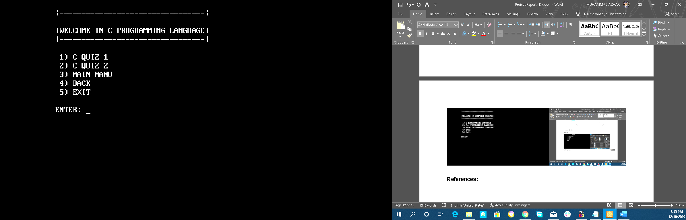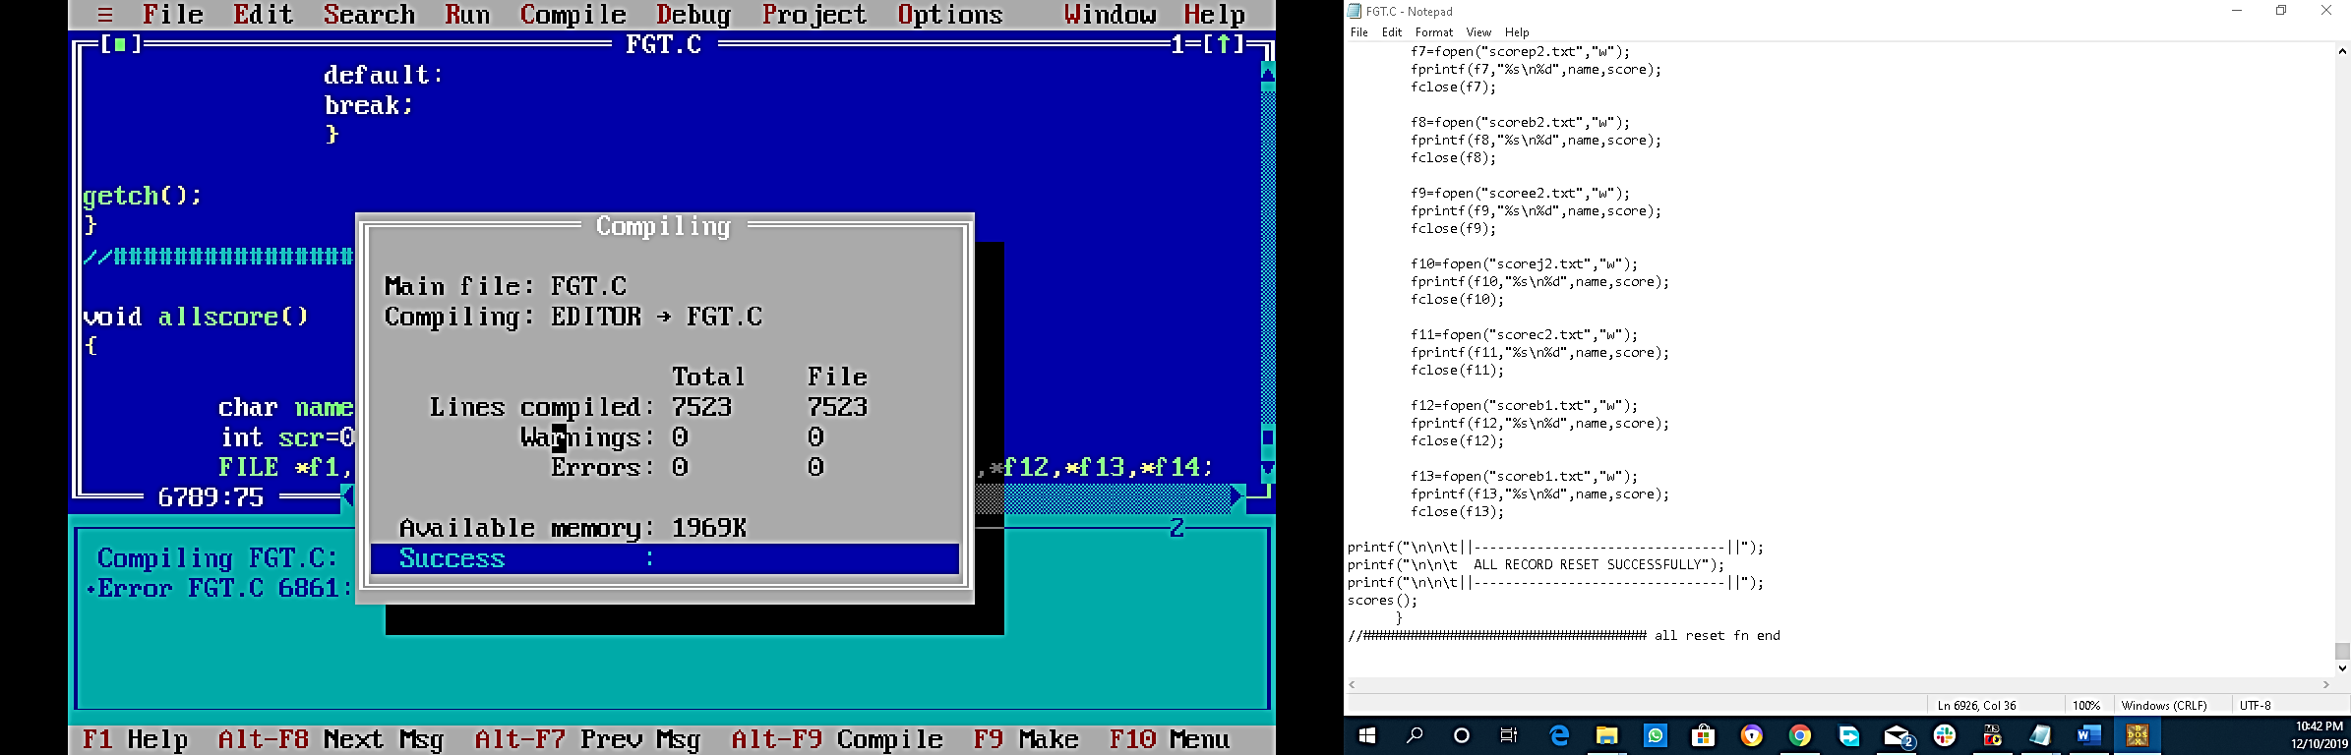

**Welcome Screen: Name Registeration:**

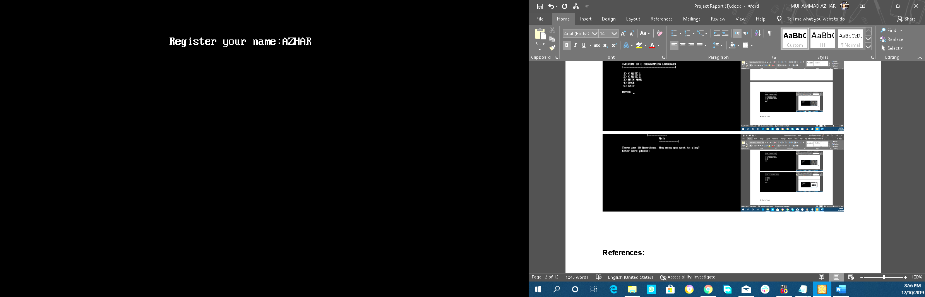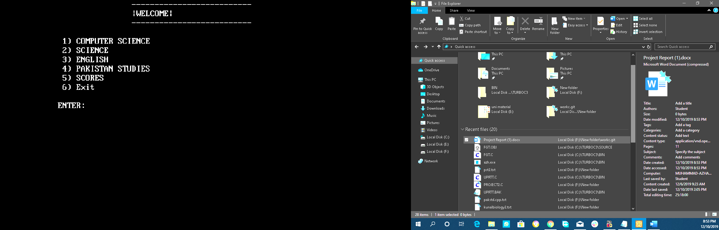

**Computer Science Section: Asking No. of Questions.**

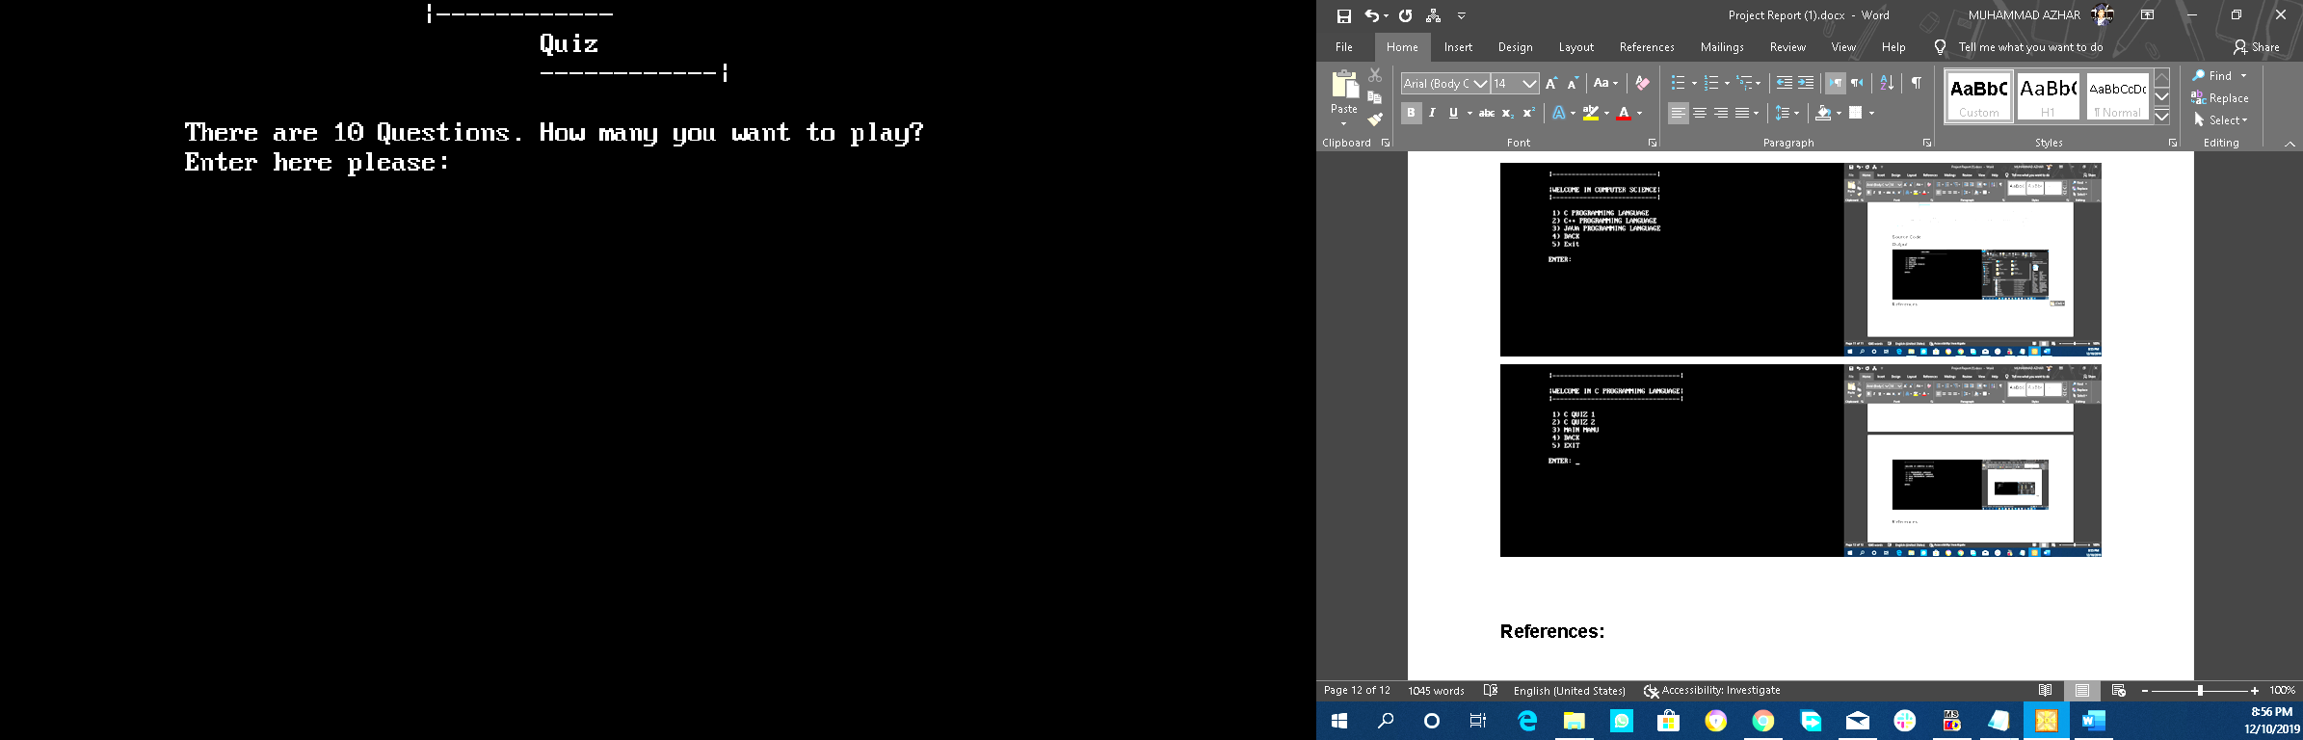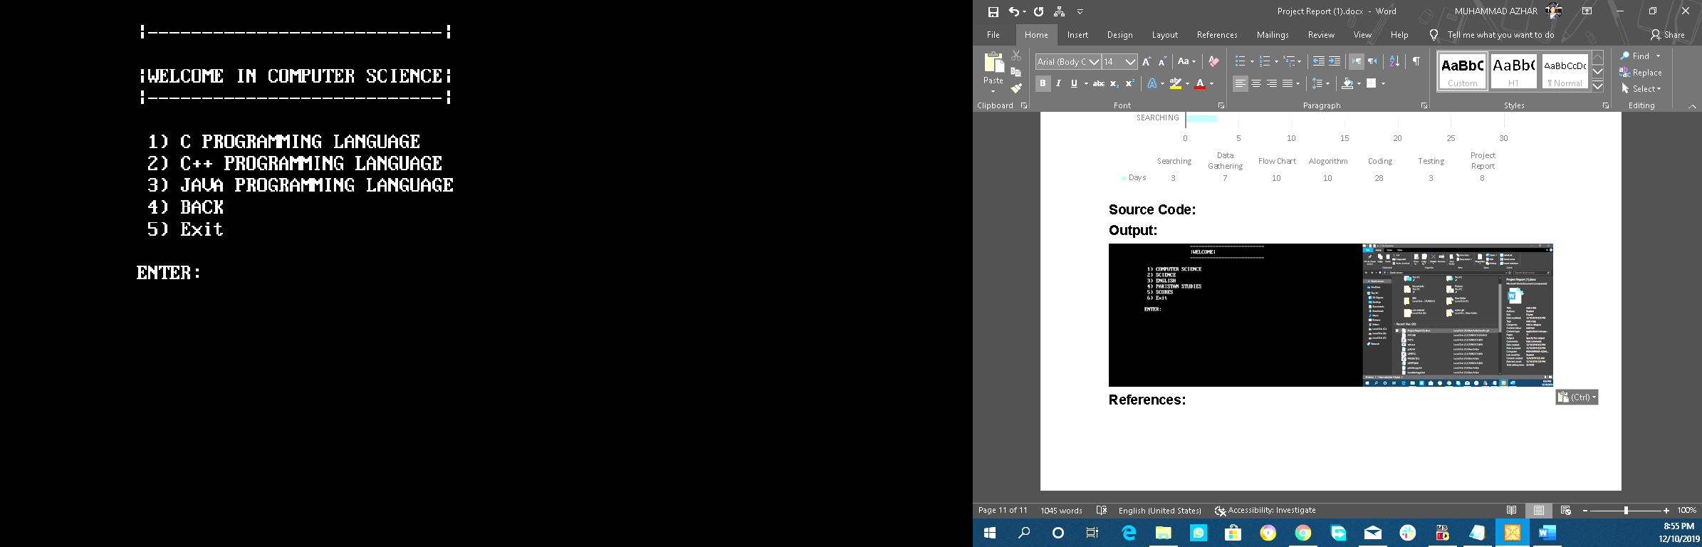

Taking Quiz. English Section:

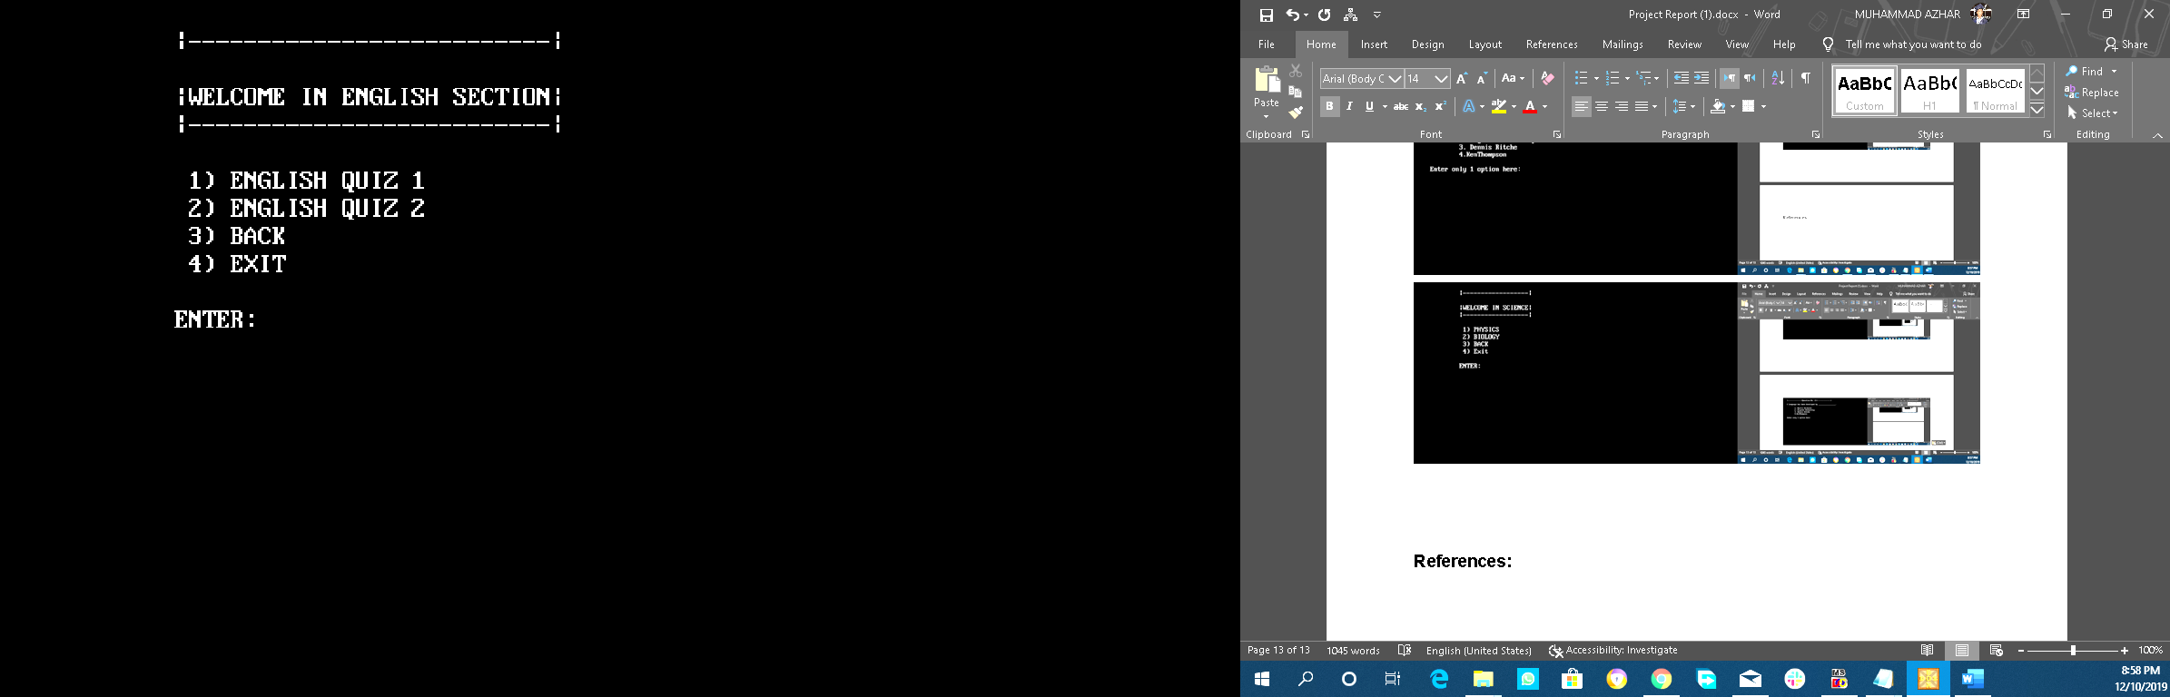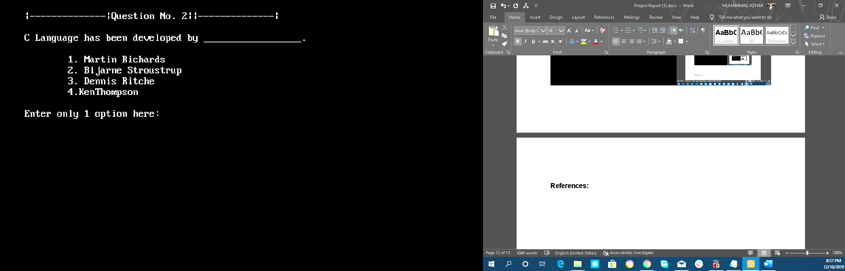

Showing Result.

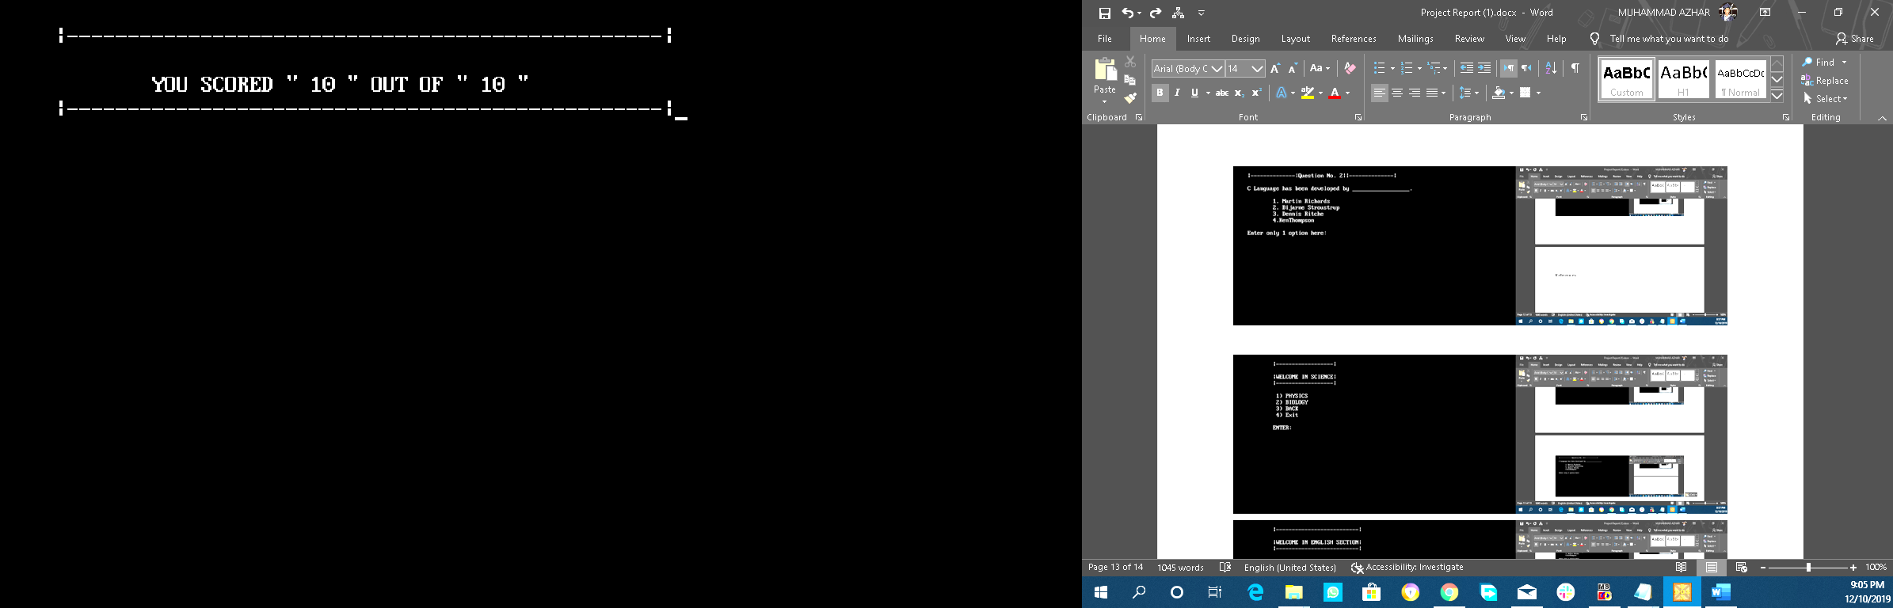

Asking what to do? Pakistan Studies Section:

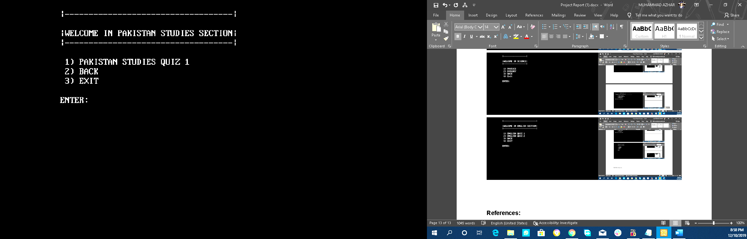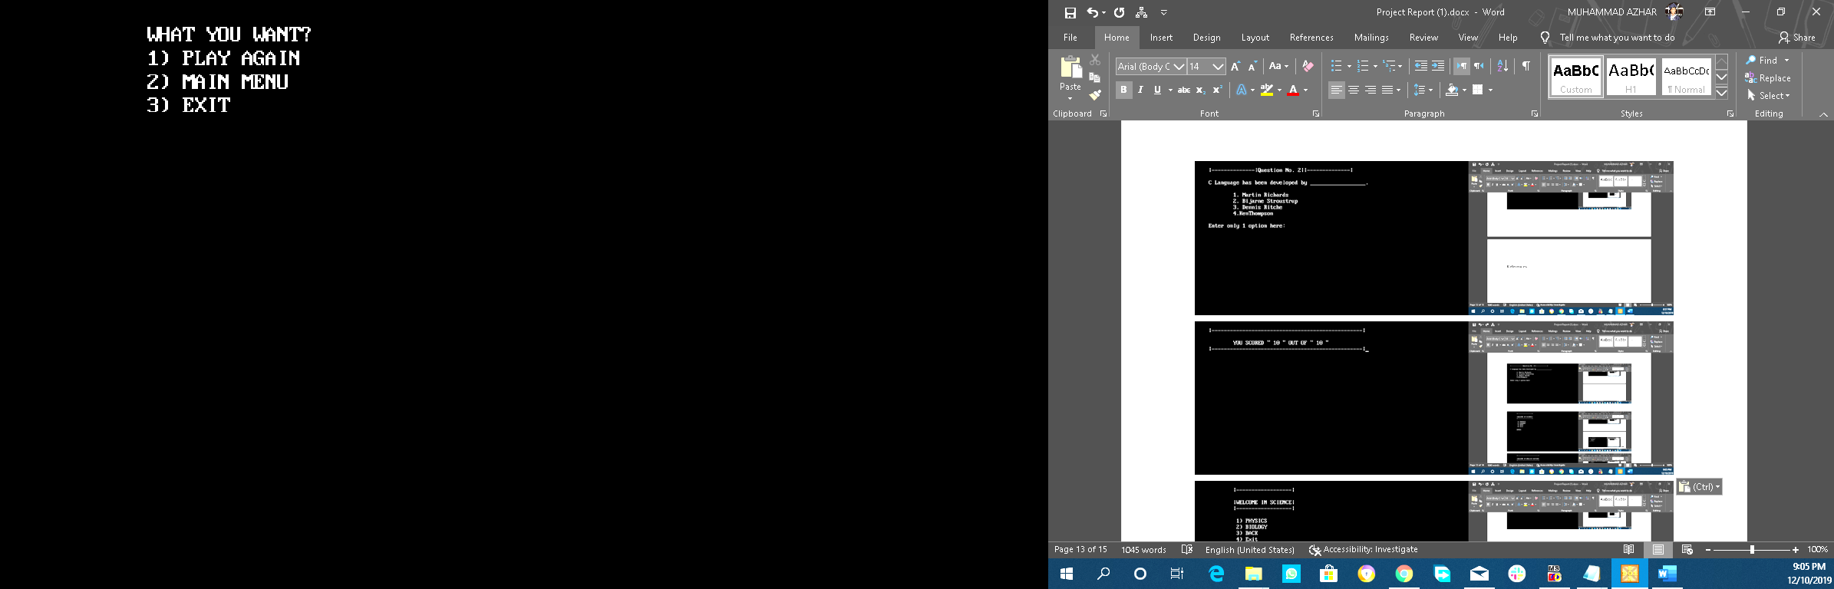

Science Section: Database:

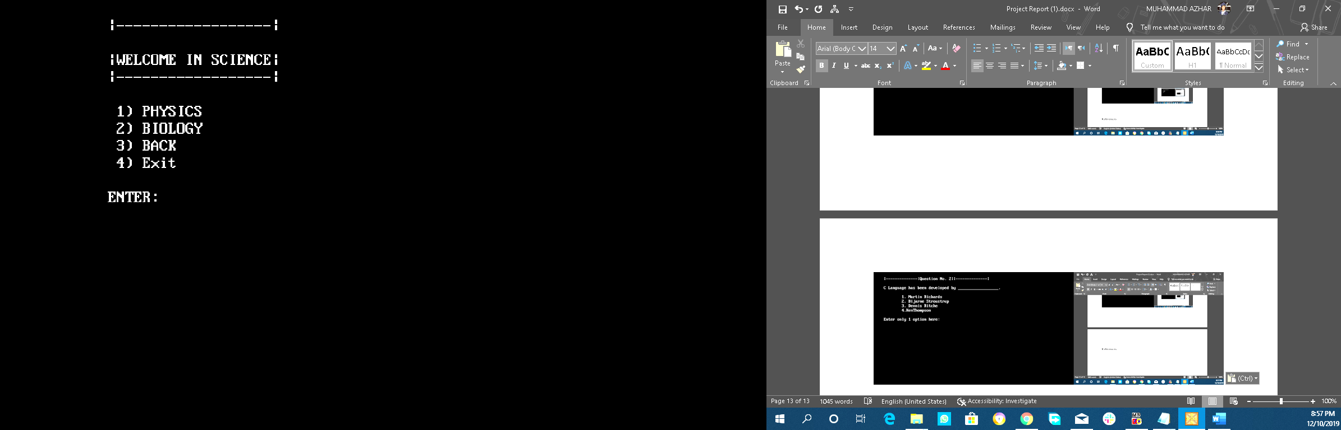

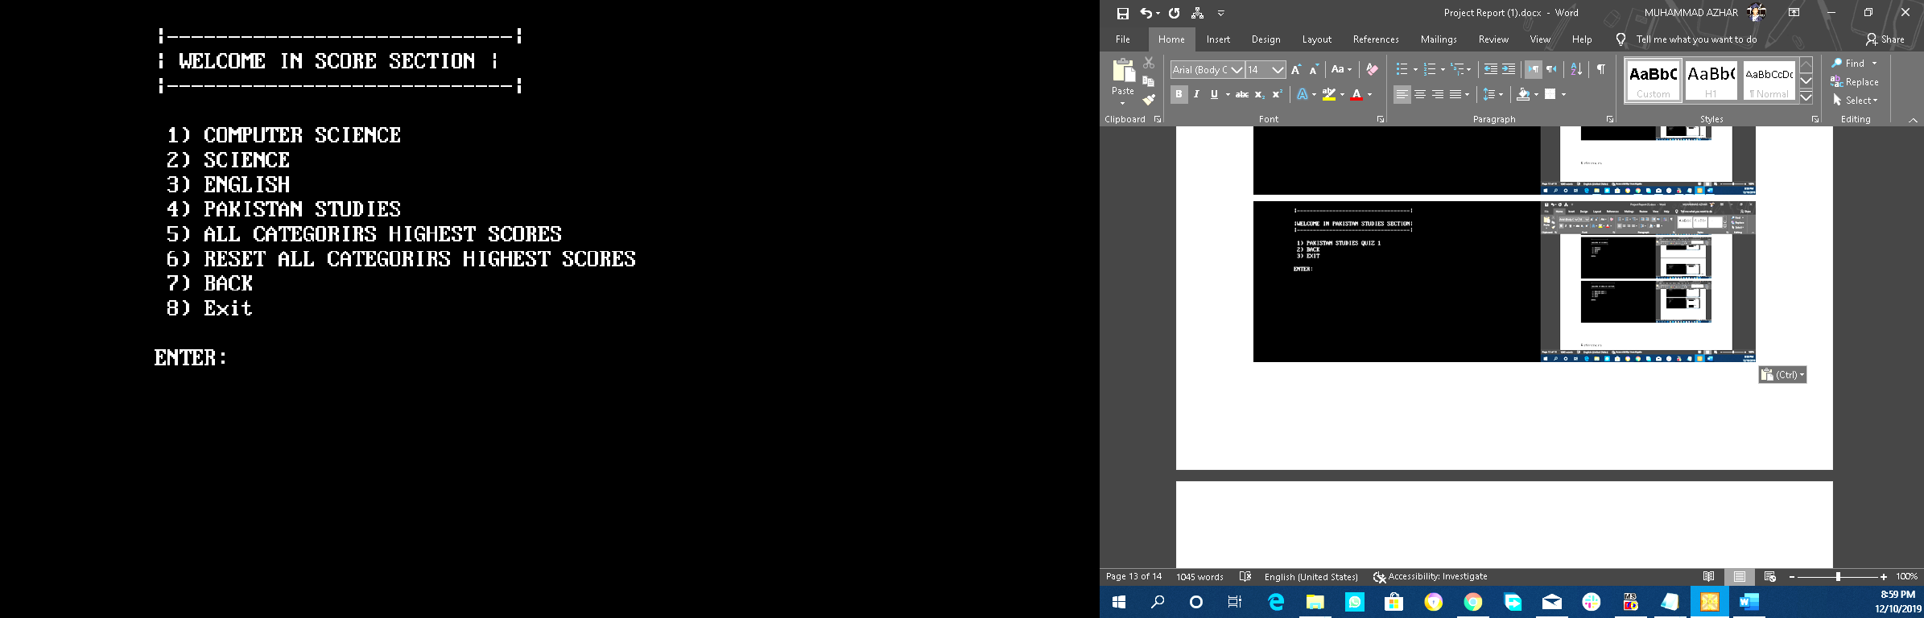

Sub Section of Computer Science(C Language):

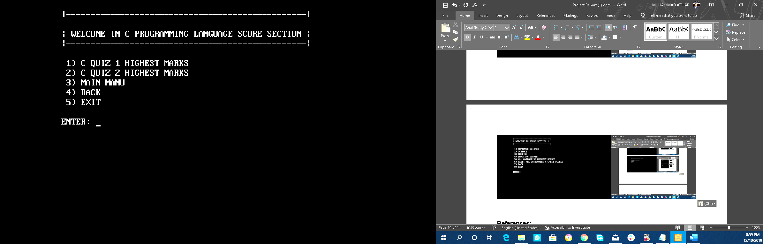

Showing Previous Results/Saved Results:

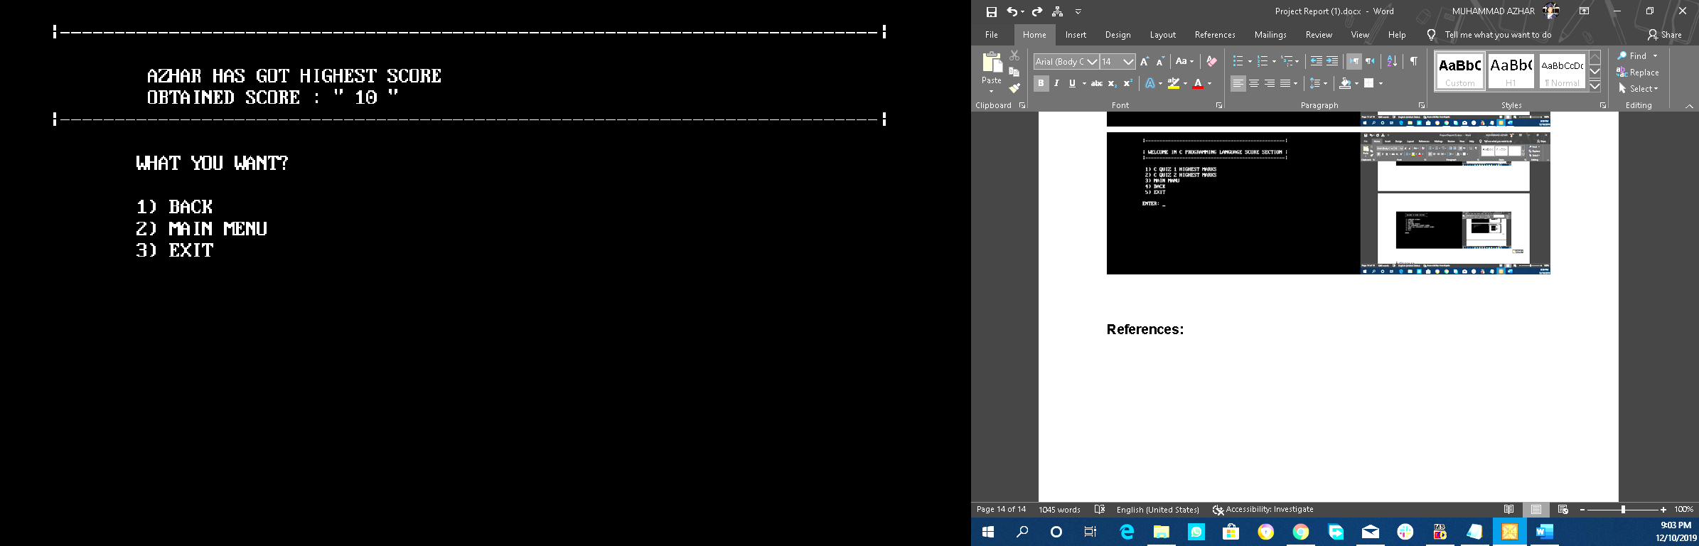

Showng all results:

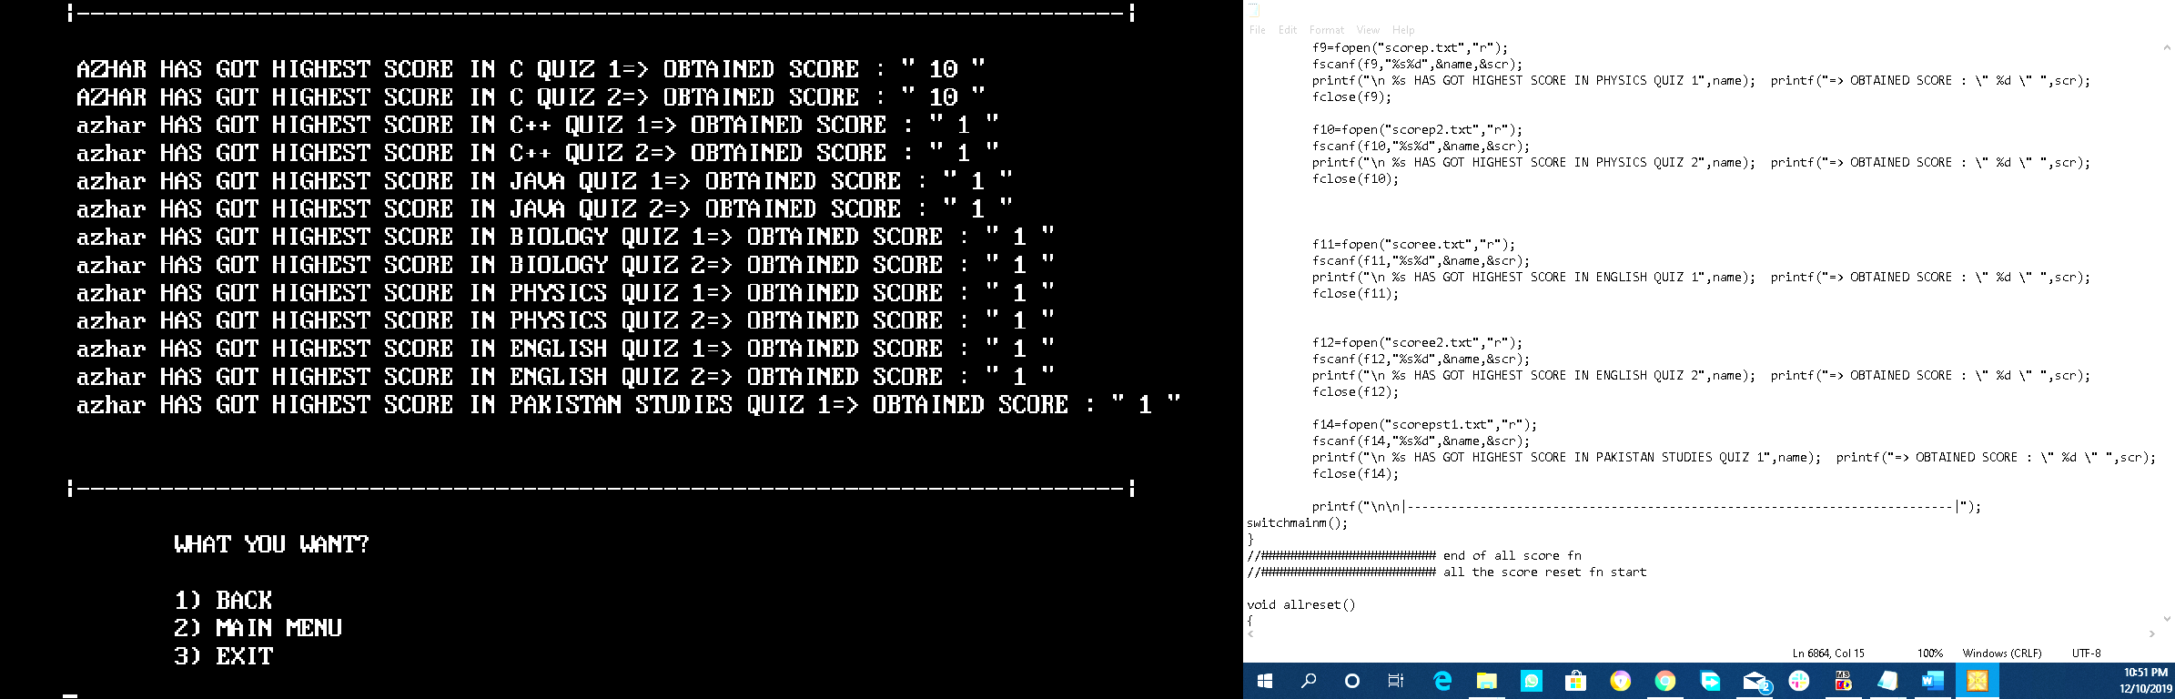

**All project releted work available on:**

[**Google Drive**](https://drive.google.com/drive/folders/17qSVoNj0It5saLsBiWCDdYRGOlDbbXQY?usp=sharing)**:**

(<https://drive.google.com/drive/folders/17qSVoNj0It5saLsBiWCDdYRGOlDbbXQY?usp=sharing> )

[**Git Hub**](https://github.com/AZHARTHEGEEK/project_q)**:**

(<https://github.com/AZHARTHEGEEK/project_q>)

References:

**Data Gathering :** <https://pakmcqs.com/>

**Flowchart :** <https://creately.com/>

**Project Workdown :** <https://planhammer.io/>